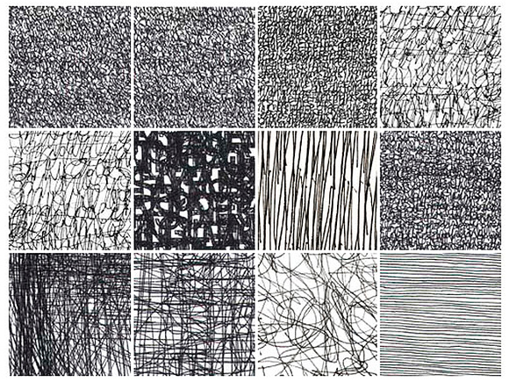
How many words can you think of that describe lines T mesmerising

